Basic Databases – Report01
Wroclaw University of Technology, Date: October 12, 2018
Student: | Email: | Grade
Identifier
First name
Last name
This task consists of 1 problem. If you cannot solve a complete problem, try to give a partial answer. Remember to write your name, and identifier.
Problem 1
Please create a database which allows you store information about books you have read, you are reading, or you are going to read.
- Analyze different ways of book specification and based on the gain information prepare conceptual data model using UML language (class diagram)
Examples of data about books:
  - Incomplete specification


A Short Introduction to Databases
Author(s): Viji Kumar
Category: Computer & Internet
ISBN
Rating: Rated: 1 times
Format: PDF, ePub, Kindle, TXT
Publisher: ?
Published: May 2016
Pages: 56
?:

  - Bibliographic specification:
- Vermeer, Leslie (2016-08-31). The Complete Canadian Book Editor. Brush Education. ISBN 9781550596779.
- Gary B. Shelly; Joy L. Starks (6 January 2011). Microsoft Publisher 2010: Comprehensive. Cengage Learning. p. 559. ISBN 978-1-133-17147-8.

  - Additional sources of book descriptions: 20 Books You Really Should Have Read By Now
https://www.rd.com/culture/14-books-you-really-should-have-read-by-now/

Create a conceptual data model taking into account the rules of the domain of mention above description
- Identify and define classes of objects including basic properties (attributes, candidate keys, constraints) e.g. Book(ISBN, Title, …)
- Define business rules
- Define class diagram

Place the results of each subtask in the in the below parts of the report

Solution
- Class definitions
  - Book – a physical entity, that is written by an author and assigned to different formats to be available for reading on any number of devices. It can have the title, a category, ISBN, it is given a rating, that is calculated as the average of all the times the book was rated, published on a certain date, contains certain number of pages.
  - Author – a person, who writes books. He has a name and a rating.
  - Publisher – an institution, that publishes books. It has a name and the registration date.
  - Format - a certain encoding of a book. This encoding is given a name.

- Business rules
#1. 1 or more authors can write any number of books.
#2. A book can be published by a publisher, and a publisher can publish any number of books.
#3. A single book can belong to any number of formats, and any format can be assigned to any number of books.

- Class diagram
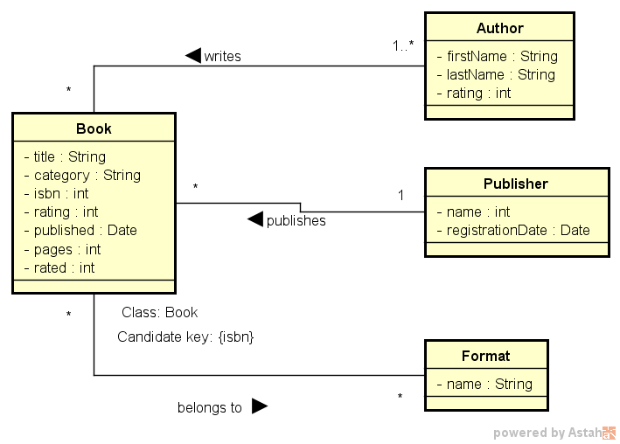
Conclusions
?

Please do not forget about the conclusions being a summary of considered problems and proposed solutions!
Remarks:
- Students' reports (as one package) should be sent by the leader of the group via e-mail before the next lab
- The rule of naming student’s file report is defined below

Name of the file: Rep01-StudId-Last name.pdf | Example: Rep01-1951355-Turan.pdf

